Using VC6 and VB

Well hello all you VB programmers. In this tutor you will learn how to use Visual C++ 6 to write a Dynamic DLL that can be called from your VB Applications.

Why would I wanted to use VC. Well there are many reasons and in you’re programming time there is always time when you need to resort to using parts of C++ were it be for simple speed tweaks or to access low level hardware.

So we shall start

Things you will need
- Visual Basic 5/6
- Visual C++ 6
- Some spare time,

Now lets start by opening up Visual C++6 below you can see the opening screen of Visual C++ 6

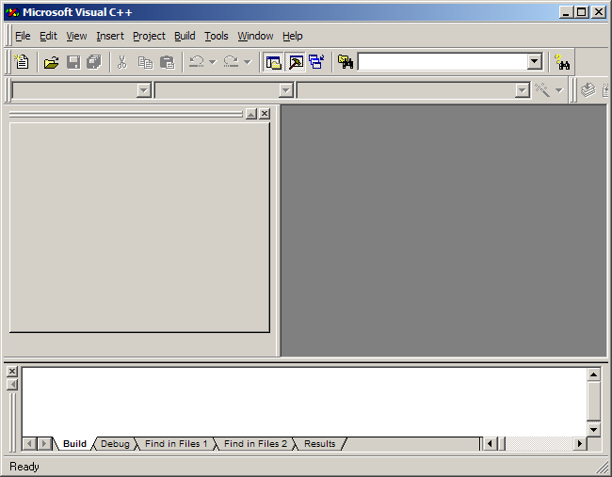

Now click File-New note the new dialog shown below:
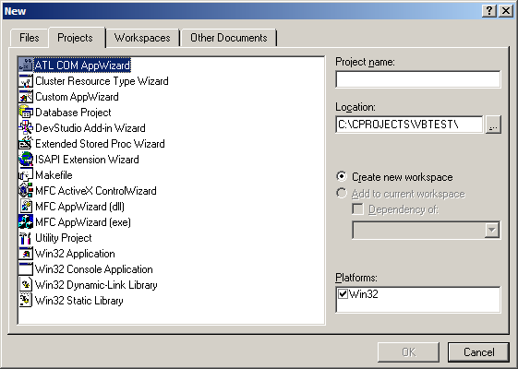

As you can see from the dialog you have many choices of projects. If you’re a VC++ programmer then you will beware of many of them. For our tutor we will only need focus on one and that is:
Win32 Dynamic-Link Library

Now click on that item form the list
Next in the Project name type in the name of the project we call it. VBTest. You may also want to change the location that is up to you,

Next Click on the OK button, and look a new dialog has been shown:

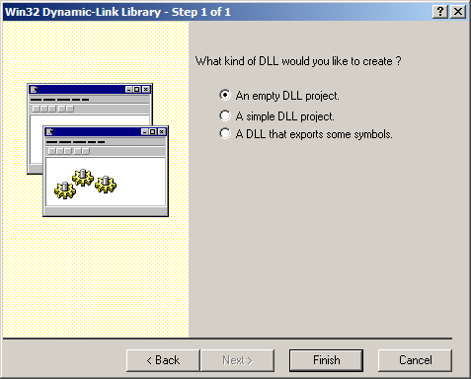

Select the option for “A Simple DLL Project” Then click on the Finish button. A new dialog will be shown showing the files that will be created for you. Just hit the OK Button.

Now we are in the Visual C++ IDE as shown below:

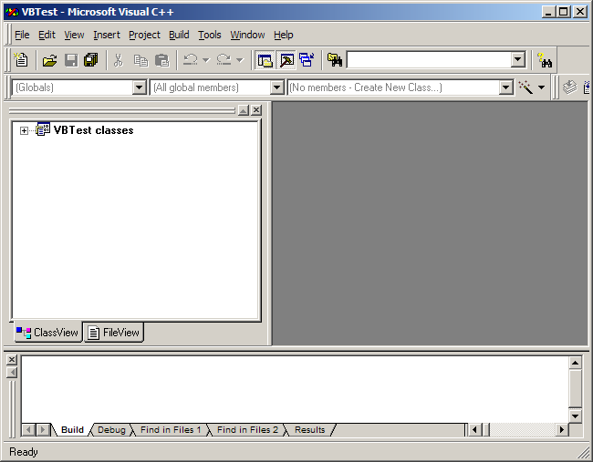

Now note the window to your left. This is the Class view were all the files of our project are kept and that we will be soon editing. Now expand this list by checking the small Cross. Next do the same for Globals you view be something like mine below:

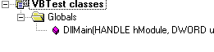
Ok so far so good. Next double click on the item for DLLMain
And you see the code editor open to the right of the screen as shown below:

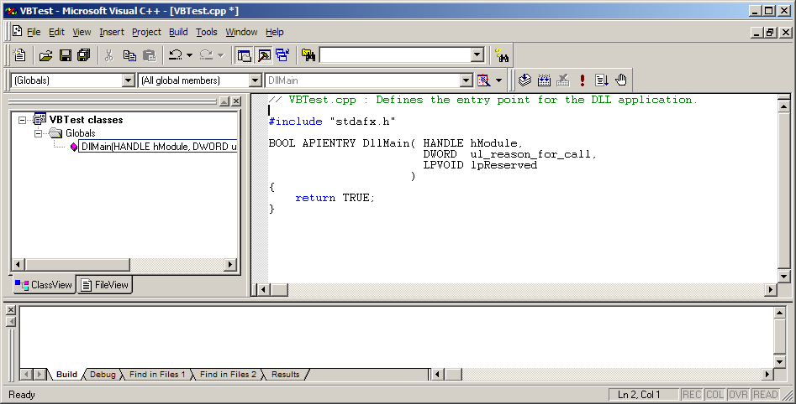

Ok what the hell is this:

BOOL APIENTRY DllMain( HANDLE hModule,
DWORD ul_reason_for_call,
LPVOID lpReserved
)
{
return TRUE;
}

Ok that is a function that the DLL needs to load in the DLL it a little like our Form_Load at this point we not need to worry our self’s about it. So just keep it as it is.

Also note above it the double /slash and the text after it. Well all that is a marker for C++ comments just like in VB only VB uses ‘

Ok so we are now going to write a small function to test that our Dll can be used in VB. For this we use something basic like adding two numbers WOW yer I know boring.

Ok so just under the function DLLMain note that the functions end with {

And type in the threw lines of code below:

//start
int _stdcall Add(int x,int y)
{
//Function to add the values of x and y
return x+y;
}
//End

Ok pretty simple a
That is almost the same, as a VB function would look like t.

Don’t type this in VC
Function Add (x as integer as integer)
Add = x+y
End function

Now save your project and lets move on

OK before we can test this DLL we need to add a new file to the project. This file will allow VB to use the functions inside the DLL

Ok do this by going to menu Project->Add to Project->New you will then see the dialog below:

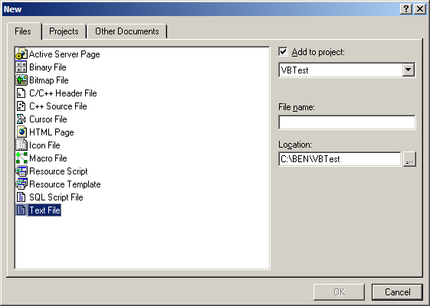

Ok go right to the bottom and select Text File
In the filename box type in VBTest.def and then click the OK button

Ok back in the IDE and now in the Class view select the other tab that says Files. Next double click the folder in the list called Source Files this will then expand the list as shown below:

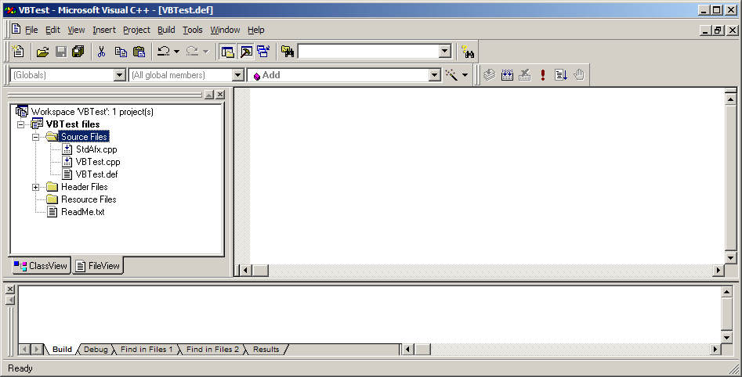

Now from the Source Files list double click on VBTest.def this will then open the editor window. Ok pretty blank. Ok now we add some text to allow our DLL to work.

Do you remember the function name from above that what we use ok first we need to add the world Exports and then our function name as shown below:

EXPORTS
Add

Ok all done. Now save your project again. Now we are going to compile the DLL do this by clicking the compile button as shown.

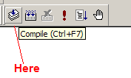

Well that’s about all we need to do in VC for now. So exit the program and fire up Visual Basic.

New Project. Add a 3 texts box and command button on to the form.

Control Caption Property Name
Command Button Add cmdADD
TextBox1 none txtA
TextBox2 none txtB
Textbox3 none txtResult

Also remove all the default text from the textboxes. Add labels if you want to make if look more fancy.

Next in the general Declarations selection of the form type in the line of code below:

Private Declare Function Add Lib "VBTest.dll" (ByVal x As Long, ByVal y As Long) As Long

Now double click on your add button and enter the code.

Dim A As Long, B As Long

A = 0: B = 0
A = Val(txtA.Text)
B = Val(txtB.Text)
txtResult.Text = Add(A, B)
Well we are almost done, Now save your project.
Next find the compiled DLL from our VC Project it should be in C:\VBTest\Debug\VBTest.dll
Now copy that DLL file to the same folder were you VB project is saved to.

Ok your ready to run. Compile your VB project as an exe or you can test it in VB Press F5.
Now enter two numbers into the Text boxes and holding your breath and click the Add button
If all goes well you can exhale or if something did go wrong exhale anyway and see where you may have gone wrong.

My output
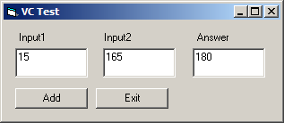

Well that is it. This project is also with this guide along with one more project showing some other neat things.

Well hope you liked this tutor.

